Week 3 - Spring Core_Maven

Exercise 1: Configuring a Basic Spring Application
Scenario:
Your company is developing a web application for managing a library. You need to use the Spring Framework to handle the backend operations.
Steps:
1. Set Up a Spring Project:
o Create a Maven project named LibraryManagement.
o Add Spring Core dependencies in the pom.xml file.
2. Configure the Application Context:
o Create an XML configuration file named applicationContext.xml in the src/main/resources directory.
o Define beans for BookService and BookRepository in the XML file.
3. Define Service and Repository Classes:
o Create a package com.library.service and add a class BookService.
o Create a package com.library.repository and add a class BookRepository.
4. Run the Application:
o Create a main class to load the Spring context and test the configuration.
Exercise 2: Implementing Dependency Injection
Scenario:
In the library management application, you need to manage the dependencies between the BookService and BookRepository classes using Spring's IoC and DI.
Steps:
1. Modify the XML Configuration:
o Update applicationContext.xml to wire BookRepository into BookService.
2. Update the BookService Class:
o Ensure that BookService class has a setter method for BookRepository.
3. Test the Configuration:
o Run the LibraryManagementApplication main class to verify the dependency injection.

Code:

Pom.xml
<?xml version="1.0" encoding="UTF-8"?>
<project xmlns="http://maven.apache.org/POM/4.0.0"
xmlns:xsi="http://www.w3.org/2001/XMLSchema-instance"
xsi:schemaLocation="http://maven.apache.org/POM/4.0.0
http://maven.apache.org/xsd/maven-4.0.0.xsd">
<modelVersion>4.0.0</modelVersion>

<groupId>com.example</groupId>
<artifactId>library_management</artifactId>
<version>1.0-SNAPSHOT</version>

<name>library_management</name>
<url>http://www.example.com</url>

<properties>
<project.build.sourceEncoding>UTF-8</project.build.sourceEncoding>
<maven.compiler.source>11</maven.compiler.source>
<maven.compiler.target>11</maven.compiler.target>
</properties>

<dependencies>
<!-- Spring Context -->
<dependency>
<groupId>junit</groupId>
<artifactId>junit</artifactId>
<version>4.13.2</version>
<scope>test</scope>
</dependency>

<dependency>
<groupId>org.springframework</groupId>
<artifactId>spring-context</artifactId>
<version>5.3.34</version>
</dependency>

<!-- Spring AOP -->
<dependency>
<groupId>org.springframework</groupId>
<artifactId>spring-aop</artifactId>
<version>5.3.34</version>
</dependency>

<!-- AspectJ -->
<dependency>
<groupId>org.aspectj</groupId>
<artifactId>aspectjweaver</artifactId>
<version>1.9.21</version>
</dependency>
</dependencies>

<build>
<pluginManagement>
<plugins>
<plugin>
<artifactId>maven-clean-plugin</artifactId>
<version>3.1.0</version>
</plugin>
<plugin>
<artifactId>maven-resources-plugin</artifactId>
<version>3.0.2</version>
</plugin>
<plugin>
<artifactId>maven-compiler-plugin</artifactId>
<version>3.8.0</version>
</plugin>
<plugin>
<artifactId>maven-surefire-plugin</artifactId>
<version>2.22.1</version>
</plugin>
<plugin>
<artifactId>maven-jar-plugin</artifactId>
<version>3.0.2</version>
</plugin>
<plugin>
<artifactId>maven-install-plugin</artifactId>
<version>2.5.2</version>
</plugin>
<plugin>
<artifactId>maven-deploy-plugin</artifactId>
<version>2.8.2</version>
</plugin>
<plugin>
<artifactId>maven-site-plugin</artifactId>
<version>3.7.1</version>
</plugin>
<plugin>
<artifactId>maven-project-info-reports-plugin</artifactId>
<version>3.0.0</version>
</plugin>
</plugins>
</pluginManagement>
<plugins>
<plugin>
<groupId>org.codehaus.mojo</groupId>
<artifactId>exec-maven-plugin</artifactId>
<version>3.1.0</version>
<configuration>
<mainClass>com.example.LibraryApp</mainClass>
</configuration>
</plugin>
</plugins>
</build>
</project>

applicationContent.xml
<?xml version="1.0" encoding="UTF-8"?>
<beans xmlns="http://www.springframework.org/schema/beans"
xmlns:xsi="http://www.w3.org/2001/XMLSchema-instance"
xmlns:aop="http://www.springframework.org/schema/aop"
xsi:schemaLocation="
http://www.springframework.org/schema/beans
http://www.springframework.org/schema/beans/spring-beans.xsd
http://www.springframework.org/schema/aop
http://www.springframework.org/schema/aop/spring-aop.xsd">

<aop:aspectj-autoproxy />

<bean id="bookRepository" class="com.example.repository.BookRepository"/>

<bean id="bookService" class="com.example.service.BookService">
<property name="bookRepository" ref="bookRepository"/>
</bean>

</beans>

LibraryApp.java
package com.example;

import com.example.service.BookService;
import org.springframework.context.ApplicationContext;
import org.springframework.context.support.ClassPathXmlApplicationContext;

public class LibraryApp {
public static void main(String[] args) {
// Load Spring context from applicationContext.xml
ApplicationContext context = new ClassPathXmlApplicationContext("applicationContext.xml");

// Get BookService bean
BookService bookService = (BookService) context.getBean("bookService");

// Use the service
bookService.addBook("The Great Gatsby");

// Close context if needed (for older Spring versions)
((ClassPathXmlApplicationContext) context).close();
}
}
LoggingAspect.java
package com.example.aspect;

import org.aspectj.lang.ProceedingJoinPoint;
import org.aspectj.lang.annotation.Around;
import org.aspectj.lang.annotation.Aspect;

@Aspect
public class LoggingAspect {

@Around("execution(* com.example.service.*.*(..))")
public Object logExecutionTime(ProceedingJoinPoint joinPoint) throws Throwable {
long start = System.currentTimeMillis();

Object proceed = joinPoint.proceed(); // execute method

long executionTime = System.currentTimeMillis() - start;
System.out.println(joinPoint.getSignature() + " executed in " + executionTime + "ms");

return proceed;
}
}

BookRepository.java
package com.example.repository;

public class BookRepository {
public void saveBook(String bookName) {
System.out.println("BookRepository: Saving book - " + bookName);
}
}
BookService.java
package com.example.service;

import com.example.repository.BookRepository;

public class BookService {
private BookRepository bookRepository;

// Setter for dependency injection
public void setBookRepository(BookRepository bookRepository) {
this.bookRepository = bookRepository;
}

public void addBook(String bookName) {
System.out.println("BookService: Adding book - " + bookName);
bookRepository.saveBook(bookName);
}
}

Output:
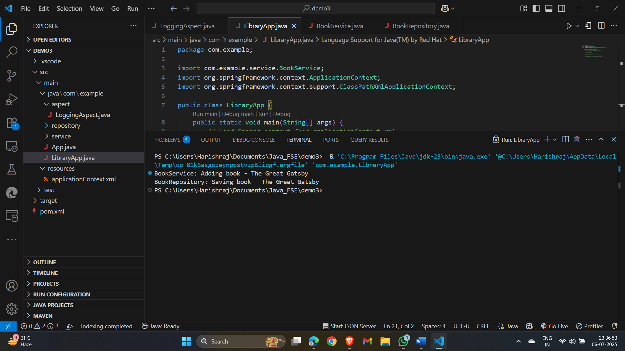

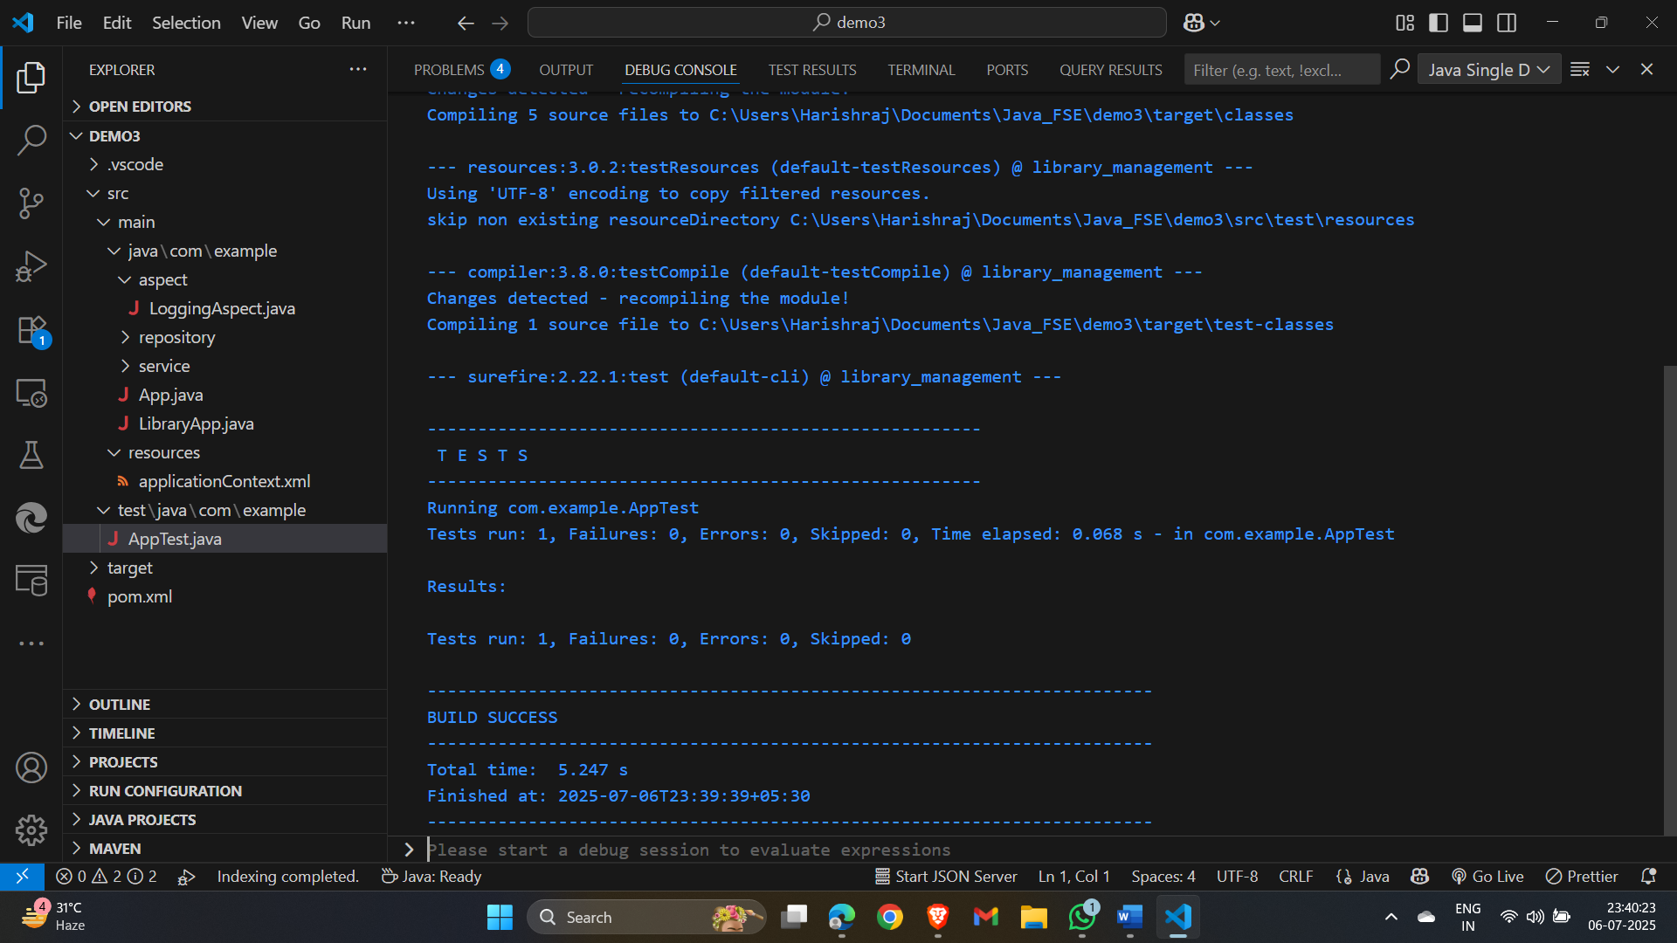

Exercise 4: Creating and Configuring a Maven Project
Scenario:
You need to set up a new Maven project for the library management application and add Spring dependencies.
Steps:
1. Create a New Maven Project:
o Create a new Maven project named LibraryManagement.
2. Add Spring Dependencies in pom.xml:
o Include dependencies for Spring Context, Spring AOP, and Spring WebMVC.
3. Configure Maven Plugins:
o Configure the Maven Compiler Plugin for Java version 1.8 in the pom.xml file.
Code:
AppConfig.java
package com.example;

import org.springframework.context.annotation.Bean;
import org.springframework.context.annotation.Configuration;

@Configuration
public class AppConfig {

@Bean
public BookRepository bookRepository() {
return new BookRepository();
}

@Bean
public BookService bookService() {
BookService service = new BookService();
service.setBookRepository(bookRepository());
return service;
}
}
BookRepository.java
package com.example;

public class BookRepository {
public void save(String book) {
System.out.println("BookRepository: Saving book - " + book);
}
}
BookService.java
package com.example;

public class BookService {
private BookRepository bookRepository;

// Setter for Dependency Injection
public void setBookRepository(BookRepository bookRepository) {
this.bookRepository = bookRepository;
}

public void addBook(String book) {
System.out.println("BookService: Adding book - " + book);
bookRepository.save(book);
}
}
LibraryManagementApplication.java
package com.example;

import org.springframework.context.ApplicationContext;
import org.springframework.context.annotation.AnnotationConfigApplicationContext;

public class LibraryManagementApplication {
public static void main(String[] args) {
// Load Spring context from AppConfig
ApplicationContext context = new AnnotationConfigApplicationContext(AppConfig.class);

// Get the BookService bean
BookService bookService = context.getBean(BookService.class);

// Call a method to test
bookService.addBook("The Spring Journey");
}
}

